**Lesion Analysis with NiiStat tutorial**

Stefan Smaczny, Hannah Rosenzopf, Lisa Röhrig

First off, you need to download all the NiiStat scripts from the NITRC page, where you can also find further information on NiiStat:

<https://www.nitrc.org/projects/niistat>  
  
The following example was carried out in MATLAB R2020b with the most recent NiiStat version (Ver 1.1) from the 27.07.2020 Github upload. In case you are using another MATLAB-version, you may have to adapt the path commands that are used in this tutorial accordingly.

**If you are unfamiliar with MATLAB:**

After unzipping the NiiStat-master.zip, we recommend copy-pasting it into your MATLAB-toolbox subdirectory (e.g., “C:\Program Files\MATLAB\R2020b\toolbox”). In order to make the scripts work, you must add their path to the current working directory.

You can either do this via the MATLAB interface…

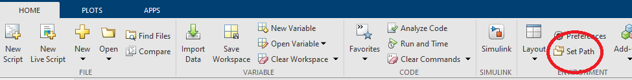

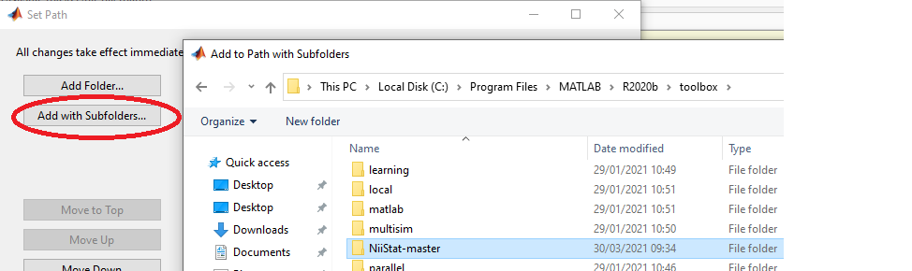

… or by typing the following into the MATLAB command line:

**addpath(‘C:\Program Files\MATLAB\R2020b\toolbox\NiiStat-master’)**

**addpath(‘C:\Program Files\MATLAB\R2020b\toolbox\NiiStat-master\NiiStatGUI’)**

**Preparation of data**

First of all, you need to convert all your .nii files into .mat files. This can be done with the **nii_nii2mat** script provided by NiiStat. If you run **nii_nii2mat** in the command line, you will get an extra window (similar to the SPM-toolbox), and then navigate to the folder where you have your lesions, and include all. When you have selected all lesions, click ‘Done’:

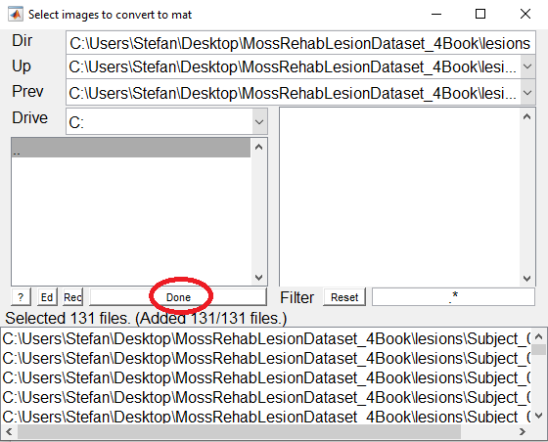

You will then be asked for the modality of the images. In our case, we are using lesions, so we just type ‘1’ and ‘OK’. This may take a while.

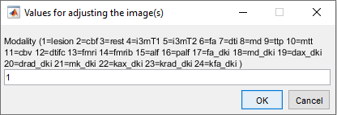  
It is necessary to bring the behavioural dataset into the format displayed in the left screenshot below:

* You need the header “participant”.
* The following header(s) you can name as you like, except that they may not contain spaces (e.g., “working memory” would not work, it would have to be “WorkingMemory”).
* It is important that the participant names are named exactly like the scan files (without the file-type extension “.nii.gz”).

Note that NiiStat tests data one-sided (it is assumed that a lesion will only worsen task performance, not improve it). Therefore, you must make sure that better performance is indicated by a higher number, while worse performance is indicated by a lower number.

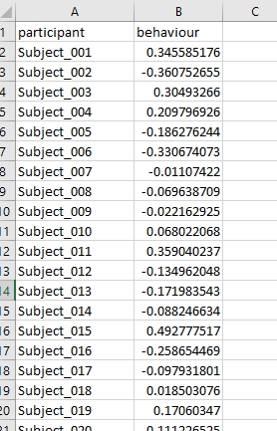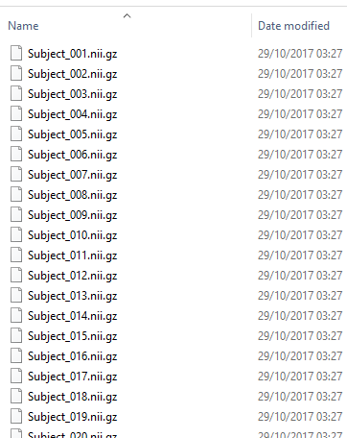

Then you must rename the data tab sheet to “NiiStat” (mind spelling and capitalisation). Save this as an .xlsx file. This file must be in the same folder as your lesion .mat files generated by nii_nii2mat!

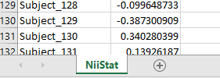

**The analysis itself**

If you want to use the GUI, you can start by typing **NiiStatGUI** in the command line. Then you should get the window presented below. (Note that some may experience issues when using NiiStatGUI, if you do, there are other possibilities further below)

In **Data Dir**, you indicate the directory where you have your lesion data as well as your behavioural .xlsx file.

In **Output Dir**, you provide the directory where NiiStat should create the results folder.

In **Excel File**, you are prompted to select your behavioural data file.

**Minimum overlap** provides the minimum amount of patients that need to have damage to a certain voxel for it to be included in the analysis. In this example, we picked 5.

Then you need to choose your method of multiple comparison correction. The suggested “gold standard” on the NITRC website is the **Normal Permutation** approach with at least 5000 permutations. In this example, we chose 1000 in order to save time, as the analysis can take a while.

In **Corrected p Threshold,** you can provide the threshold against which you would like to test.

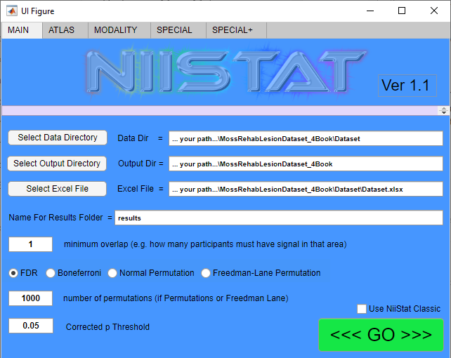

You also need to specify the modality of your images. Go to the tab “MODALITY” to see available choices. In our case, we are using lesion data, so we select just that.

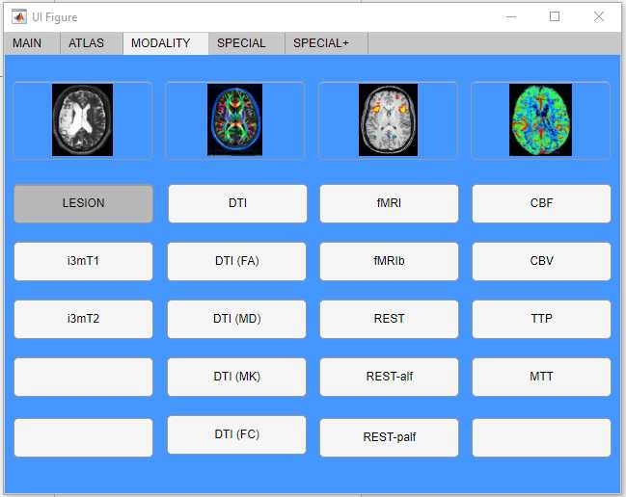

If you are interested in more specialized analyses, such as ROI analyses, regressing over lesion sizes, etc. – you can check the other options and select whatever is relevant to you. When you are ready, you can move back to the “MAIN” tab and click “GO”.

--------------------------------------------------------------------------------------------------------------------------------------

Some people experience issues with the standard GUI, therefore you can also tick the “Use NiiStat Classic” box in the MAIN tab, then click “GO”. Alternatively, you can just type **NiiStat** into the MATLAB command line.

In that case you are prompted to provide the behavioural excel file:

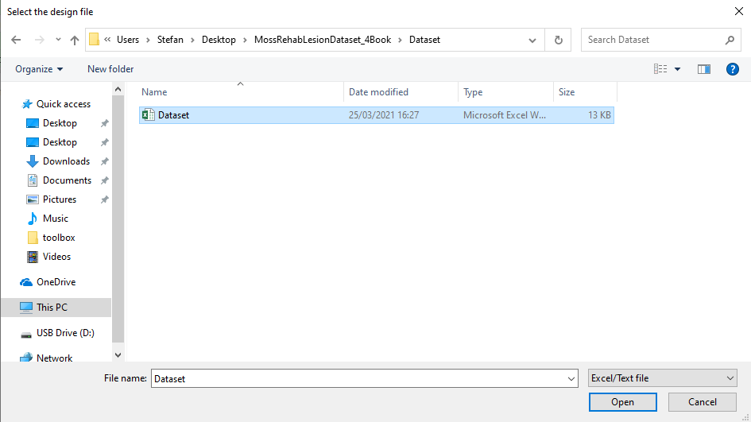

Afterwards you get the following menu, whereby you can enter all the information analogously as above. If you are ready, you can click “OK” to get an output.

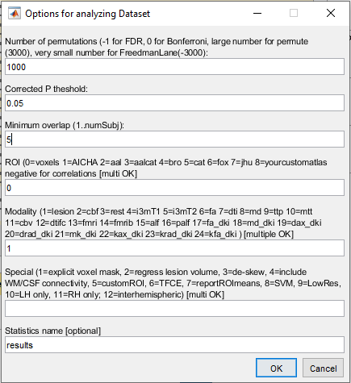

**Output**

Whichever method you chose, if everything worked out your MATLAB command line should look kind of like this:

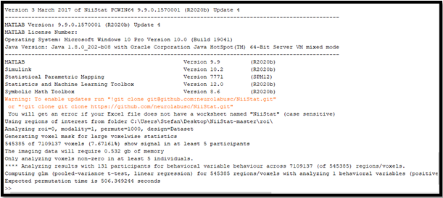When the analysis is done, you will get this output:



If you navigate back to your original folder, you should now have a “niistat_cfg.mat” file as well as a results folder with the exact date and time it finished (for example, “results_26Mar2021_120254”). Inside your results folder there should be 5 files:

**results.txt** is a text file with the output that MATLAB generated in the command line (see above).

**power.mat** is a MATLAB file that contains some summary information.

**resultssum.nii** is an overlap plot of all lesions that were included.

**Zresultsbehaviour.nii** is a topography plot of the Z-transformed voxel-based results for all voxels that were included in the statistical analysis.

**threshZresultsbehaviour.nii** is a topography plot of all voxels that were significant.

This is the result that you will end up reporting.

Here you can see a comparison of these three plots produced by NiiStat, each displayed on the ch2bet-template using MRIcron:

|  |  |
| --- | --- |
|  | |
| **resultssum.nii:**  brighter colours indicate a higher number of patients having a lesion in a particular voxel | |
|  |  | |
| **Zresultsbehaviour.nii:**  All voxels that were included in the  analysis are coloured red | **threshZresultsbehaviour.nii:**  All voxels that were included in the analysis  and were significant are coloured red | |

**Extra Notes**

* When both the behavioural data and the brain data are binomial (either zero or one), NiiStat automatically computes the Liebermeister test statistic instead of t-tests.
* Extra information can be found under the NiiStat Documentation page on NITRC:  
  https://www.nitrc.org/plugins/mwiki/index.php/niistat:MainPage